Data Story: US Toy Producers (2005–2016)

Introduction
This data story examines the transformation of toy production within the United States from 2005 to 2016. Based on information from every U.S. state, we seek to identify major trends, note significant patterns, and share useful insights regarding the industry during the 11 years of this time frame.
National Trend Analysis
The count of toy makers in the United States has consistently fallen over the years from 811 in 2005 to 633 in 2016, down by 22%. This steady decline can be interpreted as an effect of globalization, technological disruption, and shifting consumer trends. The following chart illustrates the trend: 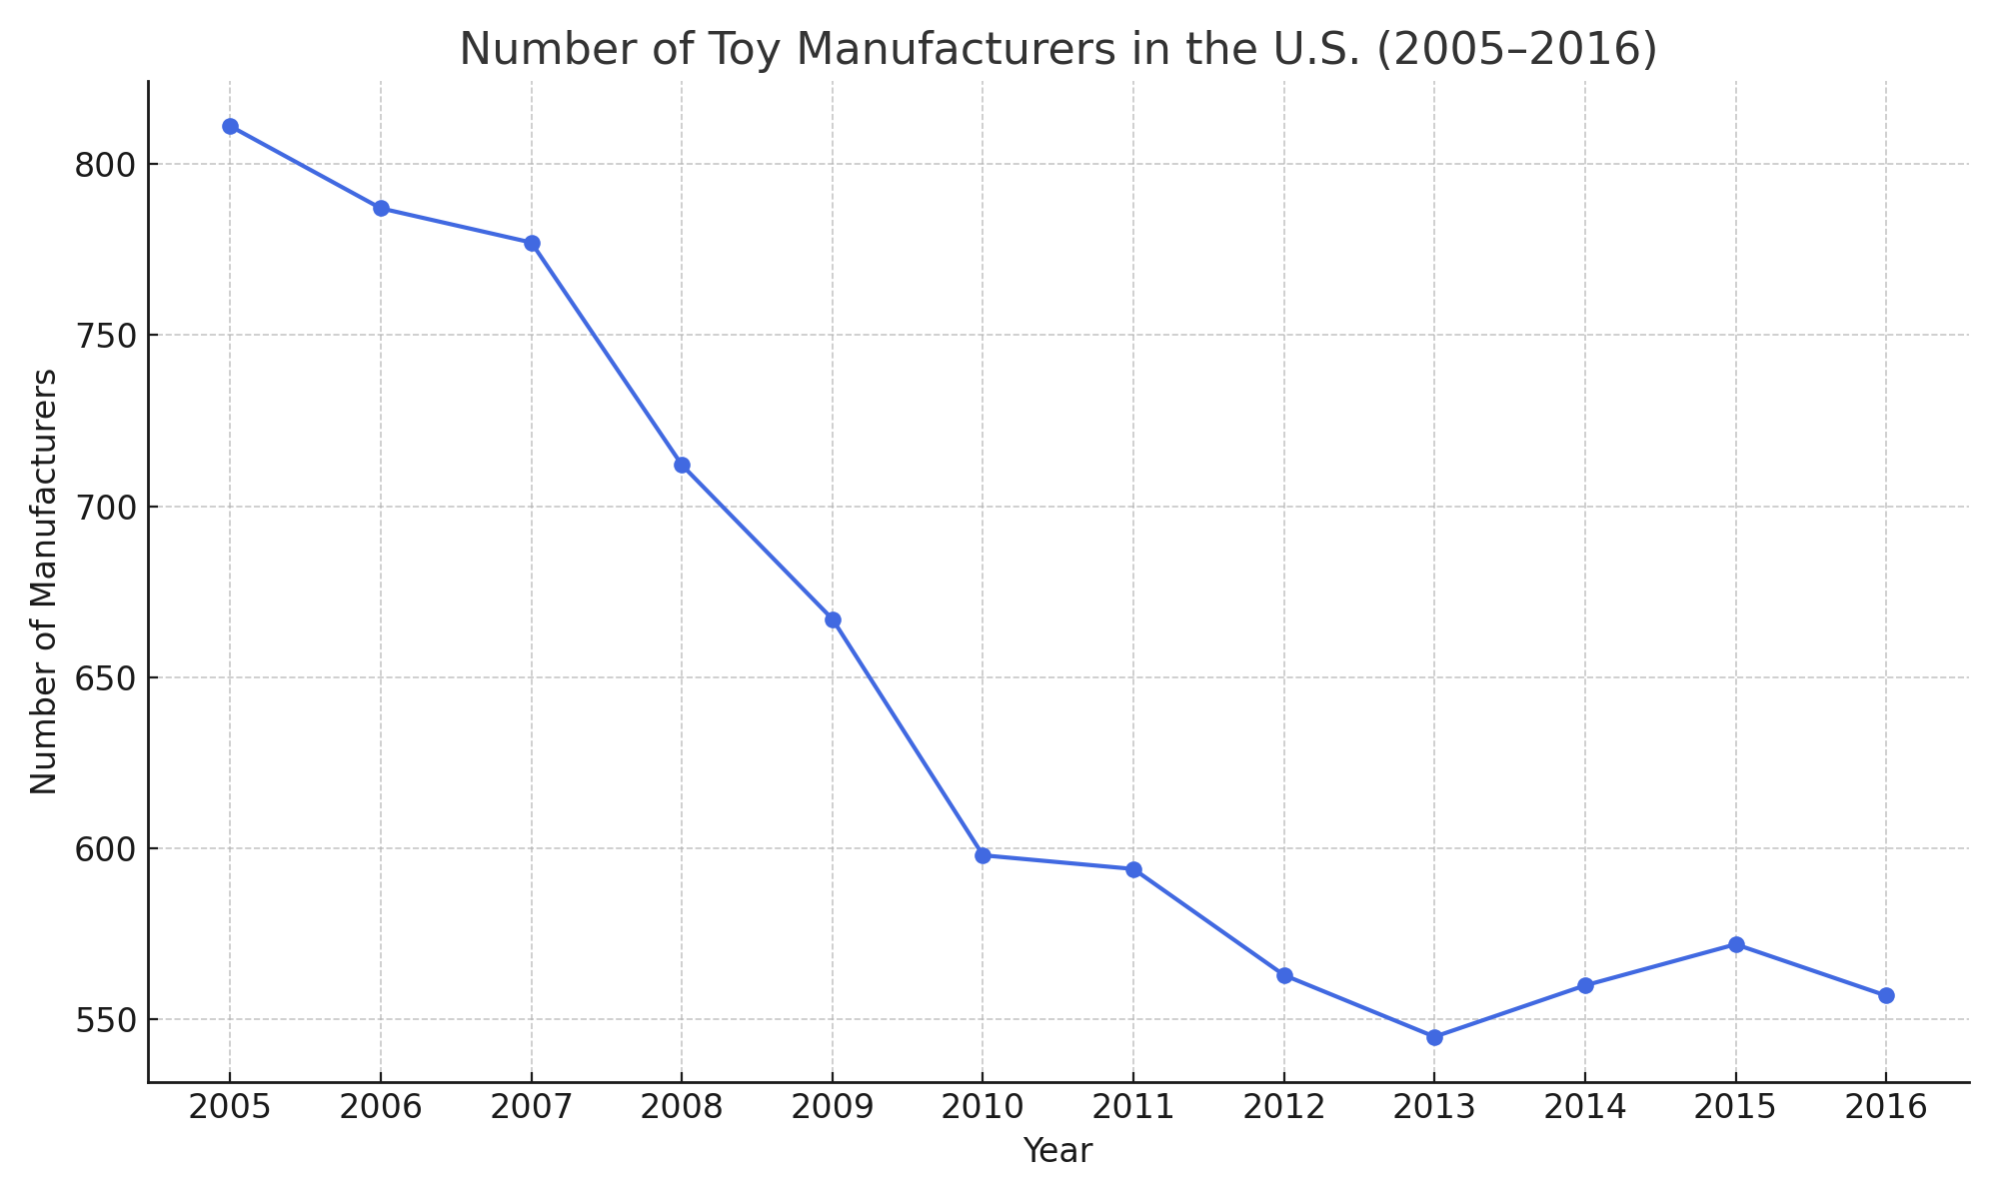

Key Takeaways
- Steady fall over 11 years.
- Possible reasons: outsourcing, rising costs, digital disruption.
- No notable recovery or boom years noted.
State-Level Insights (Optional Section)
A closer look at particular states will yield more regional insight. For example, California, New York, and Texas regularly had higher numbers, whereas numerous states had low and consistent numbers.
Conclusion
This research points to a gradual but definite narrowing of the traditional toy manufacturing sector in the U.S. These results point to the need for innovation and flexibility amid a changing marketplace. Additional studies might investigate global competition, mergers/acquisitions, or the growth of tech-based toys.

State-Level Insights (Optional Section)
A deeper dive into specific states can provide more localized understanding. For instance, California, New York, and Texas consistently had higher counts, while many states maintained low and stable numbers.

Conclusion
This analysis highlights a gradual but clear contraction in the traditional toy manufacturing industry in the U.S. These findings underscore the importance of innovation and adaptability in an evolving consumer landscape. Further research could explore global competition, mergers/acquisitions, or the rise of tech-integrated toys.

